"Los Angeles 1955-1985: The Birth of an Artistic Capital"; Centre Pompidou, Paris

Citation metadata
Author: Thomas Lawson
Date: Sept. 2006

Document controls
"Los Angeles 1955-1985: The Birth of an Artistic Capital"
CENTRE POMPIDOU, PARIS
NOW THAT LOS ANGELES has been recognized as a major center of contemporary art production, inquiring minds want to know how the city's art world accounts for itself. We might start by asking what it has to offer in the way of an originating myth. The answer is the Ferus Gallery, which mutated from Beat collective in the late '50s to high-powered commercial enterprise a decade later and is accorded mythic status not because of the history of its programming but because it happened to stage the first exhibition of the Pop art of Andy Warhol. Thus the conventional art history of Los Angeles owes its validation to New York, and this subtly condescending perspective deep-sixes the real particularity of LA by pointing to distracting local color: cars, surfing, Hollywood.
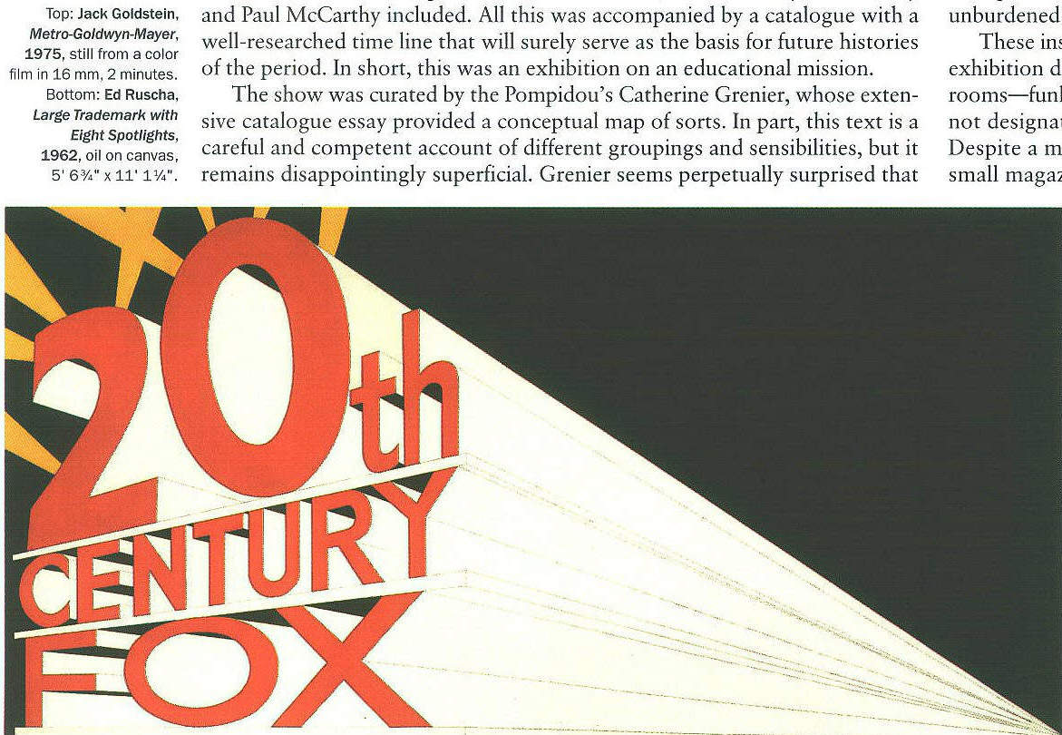
This past spring the Centre Pompidou mounted a historical survey of this provincial art scene (and provincial it undoubtedly is, even if names like "Baldessari," "Ruscha," "Nauman," "Kelley," and "McCarthy" suggest the problematic nature of the label). Looking at a thirty-year span, 1955-85, and claiming to be the first attempt "to retrace in such breadth and depth the history of a cultural and artistic scene that has yet to find full recognition," the show was an ambitious effort to lay the foundation of a more convincing narrative, something that might serve to give a historical dimension to our understanding of what happens in LA today. It was also very thorough, encompassing the work of eighty-five artists--in addition to those cited above, inclusions ranged from Betye Saar and John Outterbridge to John Divola and Judy Fiskin to Alexis Smith and Jim Shaw. The organizers put together a film series combining a cross section of Hollywood productions that used LA as mise-en-scene--Blade Runner and Chinatown, Criss Cross and They Live--with a very full program of art films and documentaries featuring the work of, among others, James Benning, Maya Deren, Harry Gamboa Jr., and Pat O'Neill; there were also several evenings dedicated to video art, with works by Mike Kelley and Paul McCarthy included. All this was accompanied by a catalogue with a well-researched time line that will surely serve as the basis for future histories of the period. In short, this was an exhibition on an educational mission.
The show was curated by the Pompidou's Catherine Grenier, whose extensive catalogue essay provided a conceptual map of sorts. In part, this text is a careful and competent account of different groupings and sensibilities, but it remains disappointingly superficial. Grenier seems perpetually surprised that LA is not a European city, easily grasped in a visit of a day or two; she comments with a touch of bewilderment on its decentered immensity, its autocen-trism, and its "dangerous neighborhoods." One gets the sense she recognizes the problem--that just as the city does not conform to the orderly, civicminded rationale she expects, its artists don't work under the weight of historical expectations. She just appears unwilling to take this recognition as a cue to think differently. Having said that, two important points suggest themselves in the course of reading her essay and that of Los Angeles County Museum of Art curator Howard N. Fox: that the Beat subculture was hugely influential in its openness to non-European, unconventional thought and that experimentation of all kinds--with drugs and lifestyles, with philosophies and materials--was always a defining attitude. The lazy idea that LA lacks history is shown to be false by these lucid essays. At the same time there is the implicit suggestion that we consider the possibility that distance from New York and Europe created space for many ways of thinking and working that were unburdened by the idea that history is the only guarantor of significance.
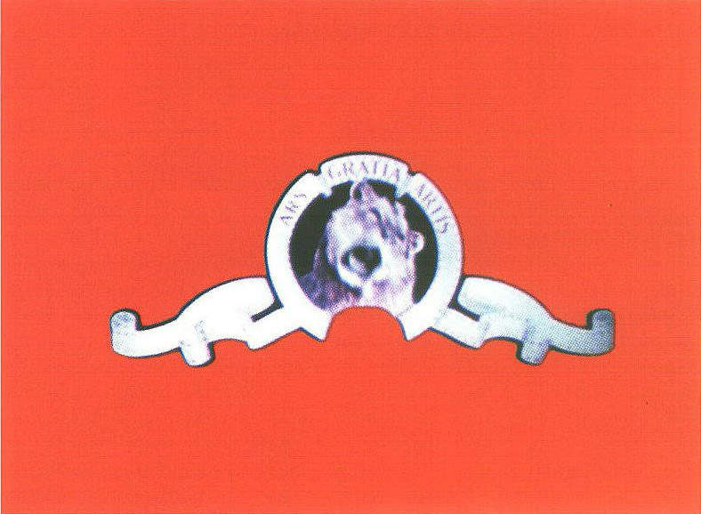
These insights, unfortunately, tended to get lost in the rather conventional exhibition design. For the most part the show unfolded as a series of themed rooms--funk, light and space, Pop, Conceptualism, and so on--which, though not designated as such, were clearly intended to delineate these categories. Despite a modest collection of documentary videotapes and vitrines full of small magazines and other ephemera, there was little attempt to provide a broader context for the work. Perhaps it is just too difficult to bring a theorized history to bear while also trying to provide an encyclopedic overview.
The exhibition's promotional image was a photograph by Dennis Hopper; the choice of this particular artist was an apparent recognition of the fact that there can be no denying the persistence of the Pop angle, the fascination with glamour and artifice. It is clear, indeed it is conventional wisdom, that movies and the culture they create have provided an abundance of source materials for Southern California artists--that abbreviated exposition, fast edits that elide time and space, and sublimated continuity are inspiration for the varied narrative strategies of Kelley, McCarthy, John Baldessari, Kenneth Anger, Allen Ruppersberg, and Jack Goldstein. The show captured this resonance with a terrific coup de theatre in its opening gallery. The room was quite small and quite dark; facing the entrance was Ed Ruscha's iconic 1962 Large Trademark with Eight Spotlights. This is a big, seemingly simple painting that plays a very complex game in which different kinds of representational systems crash into one another. It's based on the 20th Century Fox logo, with its dramatic perspectival lines and searchlight razzamatazz. At first glance, Ruscha's take on this famous image looks like a very slick piece of commercial art--but if you linger before the work it begins to collapse into painting. The typography is off, the big zero precariously coming loose from its moorings, the oversize red letters a little amateurish. The drawing of the architecture is unfinished, the coloring-in left undone. The matte blue-black background is deep and rich, and scored with the brush marks of its making. Everywhere the hand of the artist intrudes, breaking the spell of a seamless appropriation of the image's cinematic source.
As you stood in the dim gallery taking this in, you slowly became aware of the whir of a film projector. Turning around, you faced Goldstein's Metro-Goldwyn-Mayer, 1975, flickering a little uncertainly on the wall. This 16-mm film, presenting MGM's big roaring lion logo as a silent, endless loop, once seemed the sharpest conceivable use of technology as a tool for picking apart media spectacle. Long since overtaken by the exponential improvement of technology, the work now seems surprisingly tender, even affectionate. The sly deconstruction, deploying the media's own means to empty the famous trademark of signification through endless repetition, is still a brilliant piece of jujitsu. But it now appears to operate on a much more personal level, the small scale of the projection and the faltering image quality bringing Goldstein's work into alignment with the ideas about painting that animate Ruscha's work. Between these two image-conscious works, as if maintaining the balance, was John McCracken's immaculately produced Untitled, 1973. The glowing red fiberglass-and-wood bar, hung horizontally, hovered like an ellipsis, upping the ante on production values while raising the question of meaning, or its purposeful lack.
The juxtaposition of these three works established several important themes significant to an unpacking of the LA attitude: the relationship between art and the movie industry, the openness to experimentation in both materials and technique, and, above all, the unsentimental appropriation of whatever means prove necessary to the work. In the period under review, Southern California was something of a laboratory for advanced technologies, an extended community of craft-based businesses and small patent-holders, crackpot inventors, and assorted futurists with a practical bent, not to mention style-conscious subcultures like hot-rod enthusiasts, bikers, and surfers. This was an environment that provided artists with reasonable access to a lot of technical innovation and skill. The results of this unique cultural amalgam of eccentric innovation and magpie pragmatism can be seen most clearly in the materialist experiments of McCracken, as well as those of Craig Kauffman and Billy Al Bengston, artists whose work takes on a luminous, otherworldly perfectionist glow, an idealized, final-stage modernism that deserves more respect. But this sensibility is also the underpinning of the more perceptual and intellectual experiments of James Turrell, Robert Irwin, Larry Bell, and Michael Asher, who is revealed as something of a mischievous mystic. The catalogue quotes an old Asher statement: "In response to Joe Goode's window paintings of the mid-'6os, and wondering why he would not use the actual window phenomenon, I decided to open my own window and sit beside it, and feel the air as it passed through." In the show this thought was given presence in Asher's Air Column, 1960, in which you became aware of a downdraft from the building's air-conditioning as you stood in front of the wall label, puzzling out the location of the work.
What Grenier fails, disappointingly, to deliver is a more thorough exploration of the ways in which the mainstream influences of Hollywood amplify or change more rarefied or highbrow influences. After all, midcentury Los Angeles was refuge to a number of important European modernists in flight from fascism--Bertolt Brecht, Thomas Mann, Billy Wilder, Douglas Sirk. It also encouraged the creative openness of native son John Cage and provided the existential space that allowed for the cross-fertilization of the surfer mentality and the Zen mysticism of the Beats. Somewhere in that mix grew an imperative to investigate alternatives, to search for alternate forms and for modes of representing experiences as lived--not as taught. As Allan Kaprow wrote in his 1971 essay "The Education of the Un-Artist, Part I,"
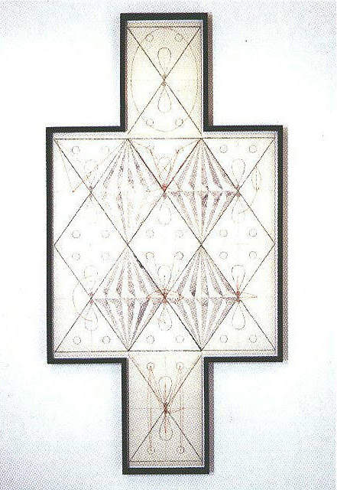

Artists cannot profitably worship what is moribund; nor can they war
against such bowing and scraping when only moments later they enshrine
their destructions and acts as cult objects in the same institution
they were bent on destroying. This is a patent sham. A plain case of
management takeover. But if artists are reminded that nobody but
themselves gives a damn about this, or about whether all agree with
the judgment here, then the entropy of the whole scene may begin to
appear very funny.
This is a politics of representation that links, in aspiration at least, work as diverse as Wallace Berman's Semina magazine project, Kaprow's happenings, and the anarchic performances of both Kelley and McCarthy--work that is deadly serious but that refuses to take itself seriously.
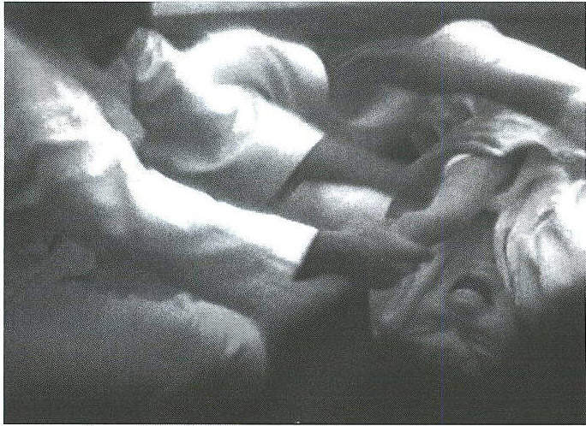
At the Pompidou, however, orthodox curatorial thinking gave us, for example, a room that lined up individual works by Saar, Outterbridge, Ed Bereal, and David Hammons like so many precious curiosities on display. In that context it was possible to grasp how the artists' expressive rage tied them to their contemporary Ed Kienholz, but it was not so easy to unpack the broader flow of ideas about found materials, nonlinear narrative, and political anger that connect them back to Berman, and forward, through various conceptual practices, to Kelley. These practices--which produced Mark di Suvero's Peace Tower, the feminist work of Nancy Buchanan and of Susan Mogul, the awe-inspiring experiments at Womanhouse, the wildly comic posturing of the collective Los Four--were here all submerged in documentation, presented in easily missed rooms of photography and videotape.
Despite the promise of that first room, with its thought-provoking juxtaposition of work, the exhibition settled for the safety of the survey. Acknowledging the complexity and foreignness of her subject, Grenier nevertheless reproduced the familiar model of understanding that posits an innovative center with peripheral satellites creating interesting variants, and lined her exhibits up like so many specimens returned from a field trip. It is as though she knew she was onto something but couldn't muster the wherewithal to puzzle it out--a shame, really, but also an opportunity for another enterprising institution. Tate Modern?
