Joan Snyder’s Proserpina: a cycle of death and renewal
The US painter creates a diptych inspired by Kate McGarrigle’s song about pain and loss
Skye Sherwin
Fri 5 Apr 2019
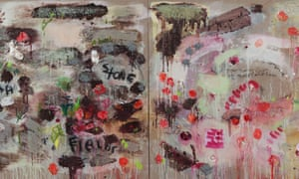
Joan Snyder’s Proserpina, 2013 (detail; full image below). Photograph: Fionn Reilly

Blood and glitter …
Joan Snyder is a grandee of US abstract expressionist painting who has been creating gloriously improvisatory and personal works since the 1960s. Lush experiments with bodily textures, offset by playful materials such as ribbons and glitter, mean this feminist pioneer’s vision is a far cry from the bombast of the ab-ex boys’ club.

Flower power …
Flowers are a favourite motif. In 2013’s Proserpina, they are created with rice paper, scattered across the canvas like wedding confetti, then painted red.

Mother knows …
This diptych is hardly light-hearted, however. It is inspired by Kate McGarrigle’s wrenching 2009 song Proserpina, composed when she was dying of cancer. In it, Proserpina’s mother laments her daughter’s half-year in the underworld. Song and painting hardwire the mother-daughter bond, and the pain at its loss.

Bitter sweet …
Fragments of the lyrics are scrawled across the canvases, which move from brutal winter hues to a sweet pink spring: a cycle of death and renewal. The petals could be bloodspots, the continued eruptions of grief. Skye Sherwin

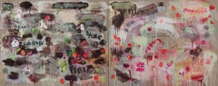

Photograph: Fionn Reilly
Blain/Southern, W1, to 11 May

